WORK SHEET - 3
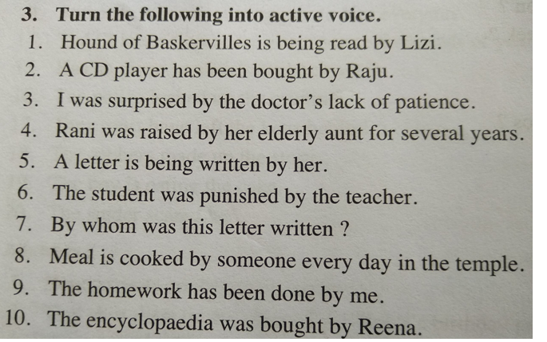
1. Lizi is reading a Hound of Baskervilles.
2. Raju has bought a CD player.
3. The doctor’s lack of patience surprised me.
4. Her elderly aunt raised Rani for several years.
5. She is writing a letter.
6. The teacher punished the student.
7. This letter is written by whom?
8. Everyday someone cooks the meal in the temple.
9.I have done the homework.
10.Reena bought the Encyclopaedia.

